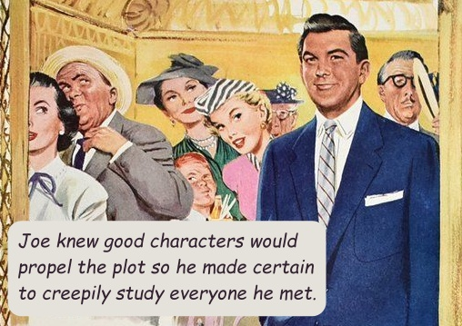
WORKSHEET “Writing Amazing, True-to-Life Characters”

Character and plot are the two main ingredients of excellent fiction. Characters bring your plot to life. Let’s look into HOW to create good characters and HOW to bring them to life.

Character is the basis (and catharsis) for every element of the book: the journey, the conflict, the suspense, and the resolution. Each character is made up of his appearance & his personality. Jot your guy down!

I : Appearance …it’s more than a pretty face…

- 1st look: face & body

- 2nd look: clothes, grooming, body language, voice

- 3rd look: medical background, obvious, and that which you know as his creator

- 4th look: psychology and family background (so often intertwined!)

- 5th look: his/her children, does he have them? How many, what gender? Did he have them young in life, old, average? Do they live with him? Etc.

- 6th look: education

- 7th look: employment

- 8th look: police record?

- 9th look: Finances, in the past? Now?

- 10th look: material possessions

- 11th look: romantic history

- 12th look: geography, where does he live, where does the action take place?

- 13th look: pets or animals in his life

11 : Personality
- INHERENT ABILITIES OR DISABILITIES? Is he a genius? Prodigy? Color blind? ADD? Dyslexic?

- RELIGION/SPIRITUALITY? Organized religion? At home or in-heart religion? New Ager? Etc.

- IDENTITY? Roles in life – dad, mom, son, police officer, teacher—also become our identity. How about your character?

- MORALITY? Is he prejudiced? Does he know right from wrong the way God sees it? The way man sees it? In his own mind?

- SUBCONSCIOUS PROGRAMMING? Did his parents convince him he was stupid? Did a teacher convince him he was gifted? These become stuck in the subconscious.

- ETHICS? Will he cheat on an exam even if he can’t get caught? Would he cheat on his taxes? Is he sneaky for personal gain?

- SEXUALITY? His orientation? Is he open about his sexuality or closed off? Wanton? Prudish? Etc.

- MOTIVATION? What drives him? What are his secret dreams and goals?

- FRIENDSHIPS AND CLOSE RELATIONSHIPS: you are affected by the company you keep. Who does your character hang with?

- SELF-AWARENESS / CONFIDENCE: how does he perceive himself?

- HOBBIES? What does he do for fun?

- CREATIVE / ARTISTIC IMPULSE? Does he write, paint, play a musical instrument?

- ROLE MODELS? Who does he look up to?

- WHAT ARE HIS POLITICS?

- WHAT ARE HIS VICES?

- WHAT DOES HE LIKE TO EAT?

- WHAT ARE HIS HABITS AND QUIRKS?

- IS HE CHARITABLE?

Southern Christian Writers Conference June 7 & 8, 2019 © Ellen Sallas
4

Download this worksheet as often as needed at this link: http://www.ellencmaze.com/author-appearances.php

Sections of this teaching were gleaned from THE PLOT THICKENS by Noah Lukeman. Highly recommended reading! ~ Ellen

